**EXPERIMENT NO. 03**

IMPLEMENTATION OF STATIC ROUTING USING CISCO PACKET TRACER

**EXPERIMENT NO. 03**

**AIM: -** To implement static routing using Cisco Packet Tracer.

**OBJECTIVES:**

1. To create routing topology.
2. To configure IP addresses.
3. To define static routes.
4. To check the connectivity among the devices in the network.

**SOFTWARE:** Cisco Packet Tracer 7.3.0.

**SCENARIO:**

**CONFIGURATION OF SERIAL2/0 INTERFACE OF Router0**

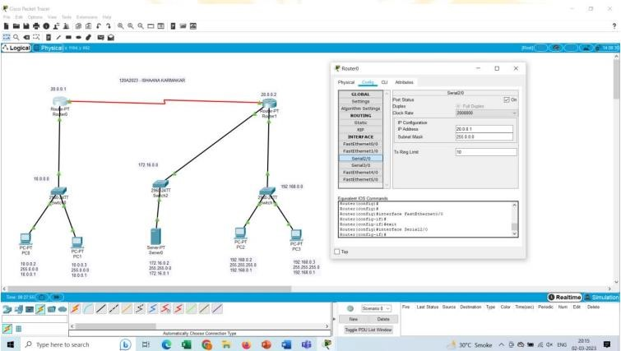

**CONFIGURATION OF FASTETHERNET0/0 INTERFACE OF Router0**

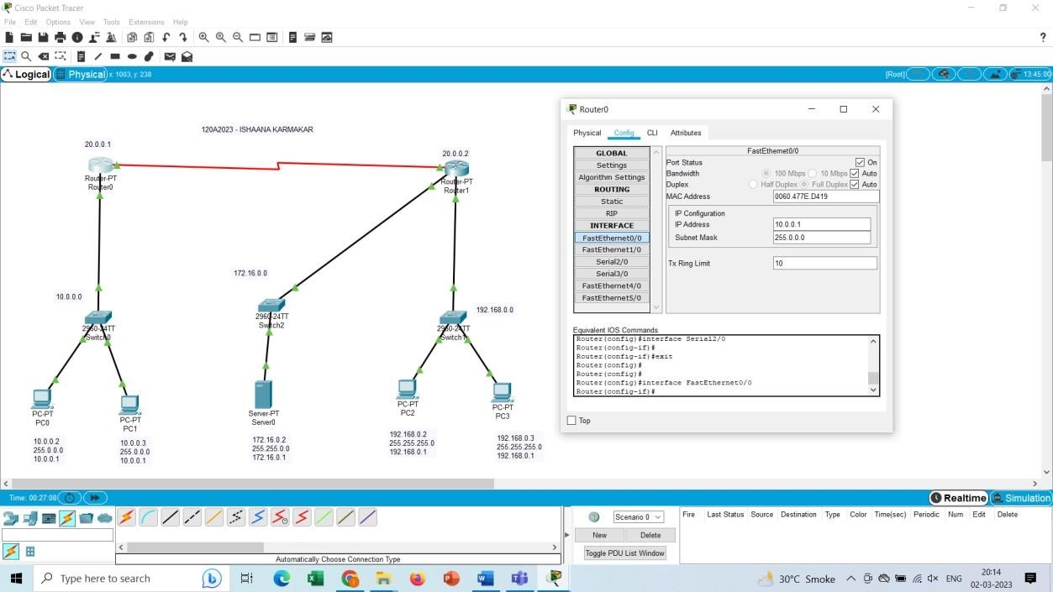

**CONFIGURATION OF FASTETHERNET0/0 INTERFACE OF Router1**

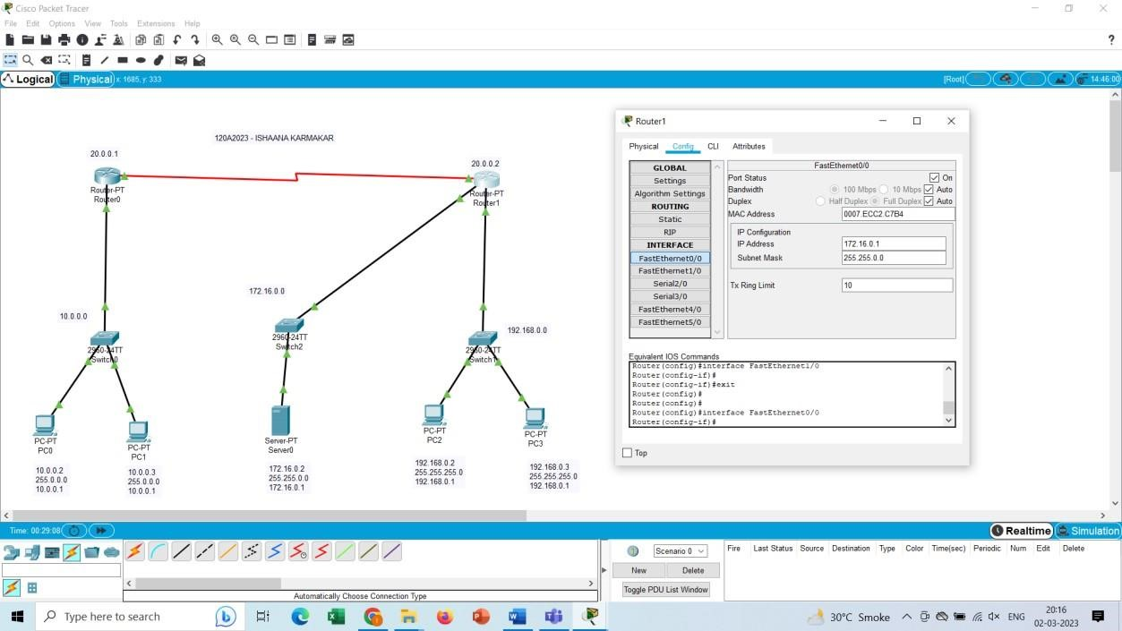

**CONFIGURATION OF SERIAL2/0 INTERFACE OF Router1**

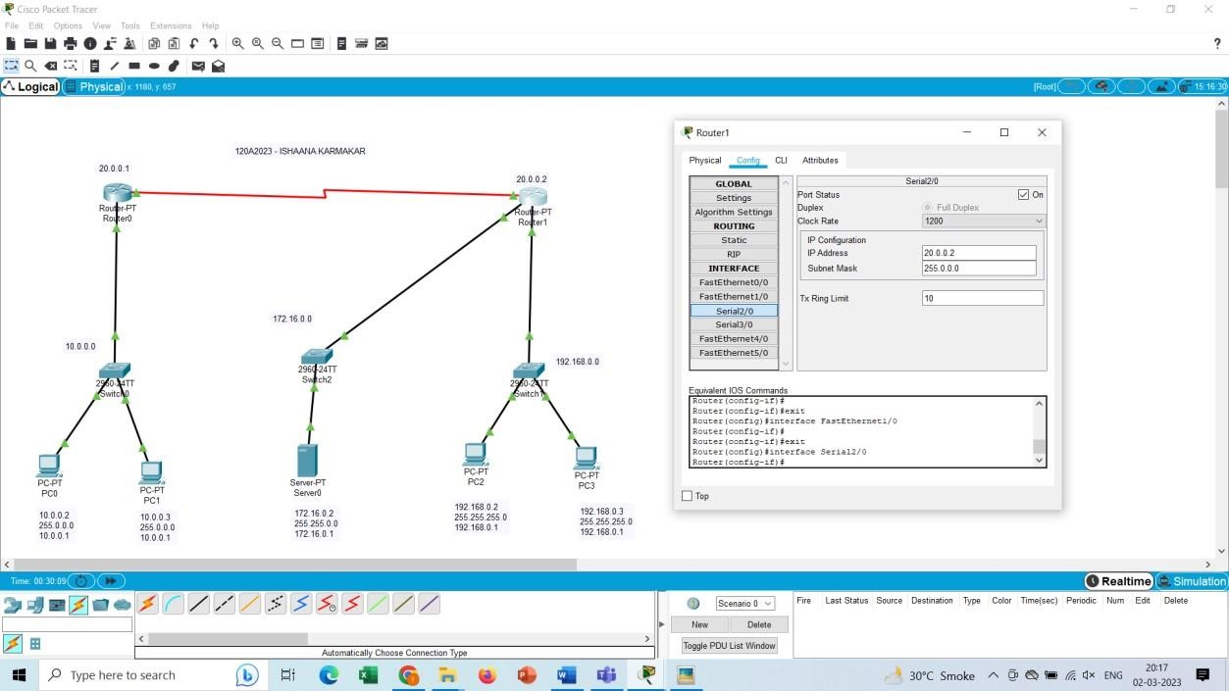

**CONFIGURATION OF FASTETHERNET1/0 INTERFACE OF Router1**

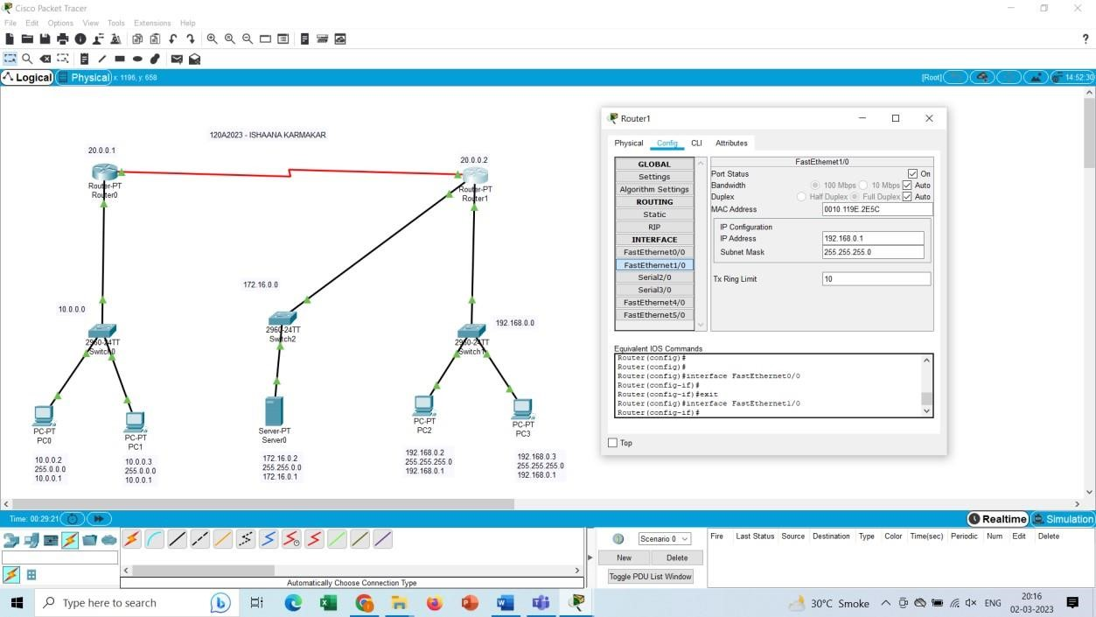

**STATIC ROUTE Router0**

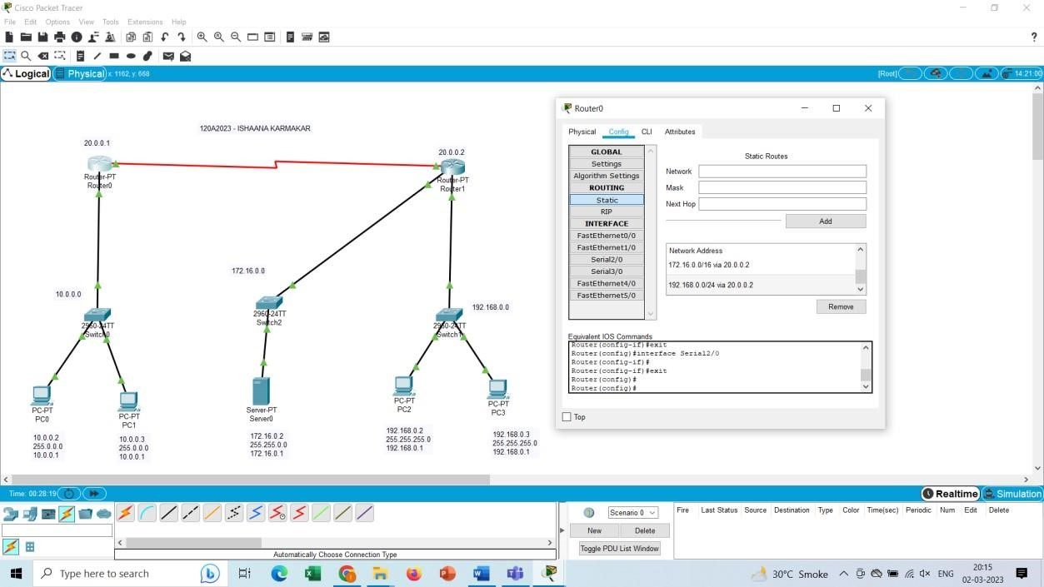

**STATIC ROUTE Router1**

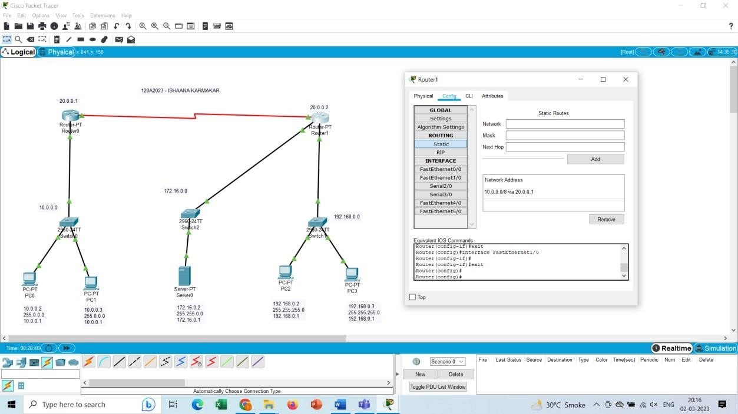

**PING RESPONSE:**

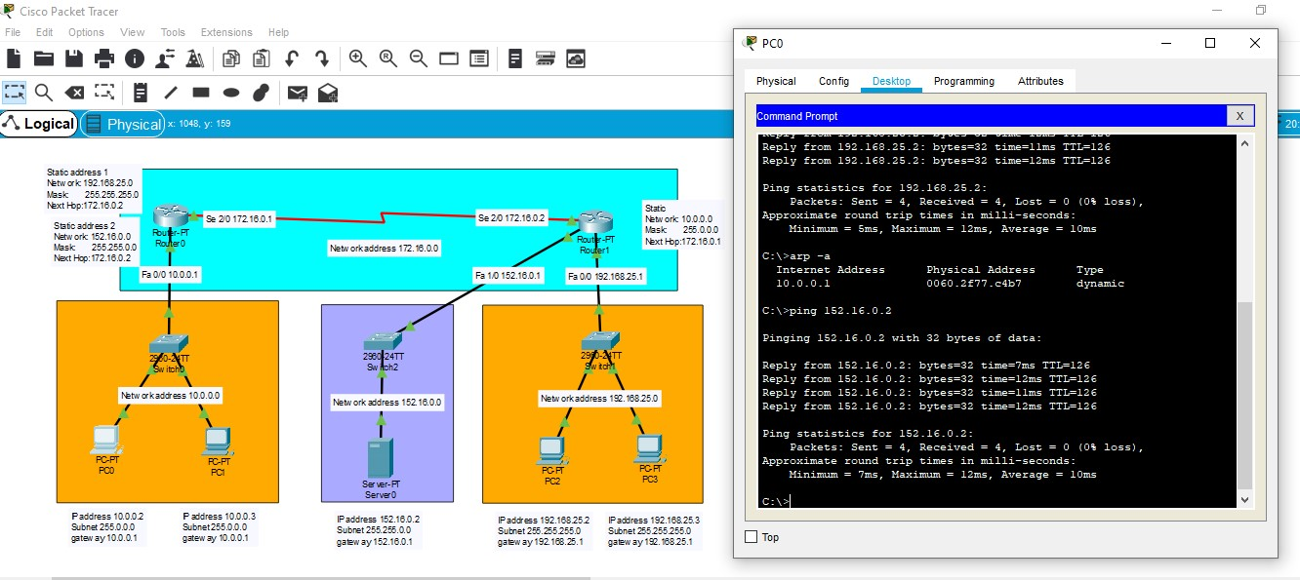

**PACKET FLOW SEQUENCE:**

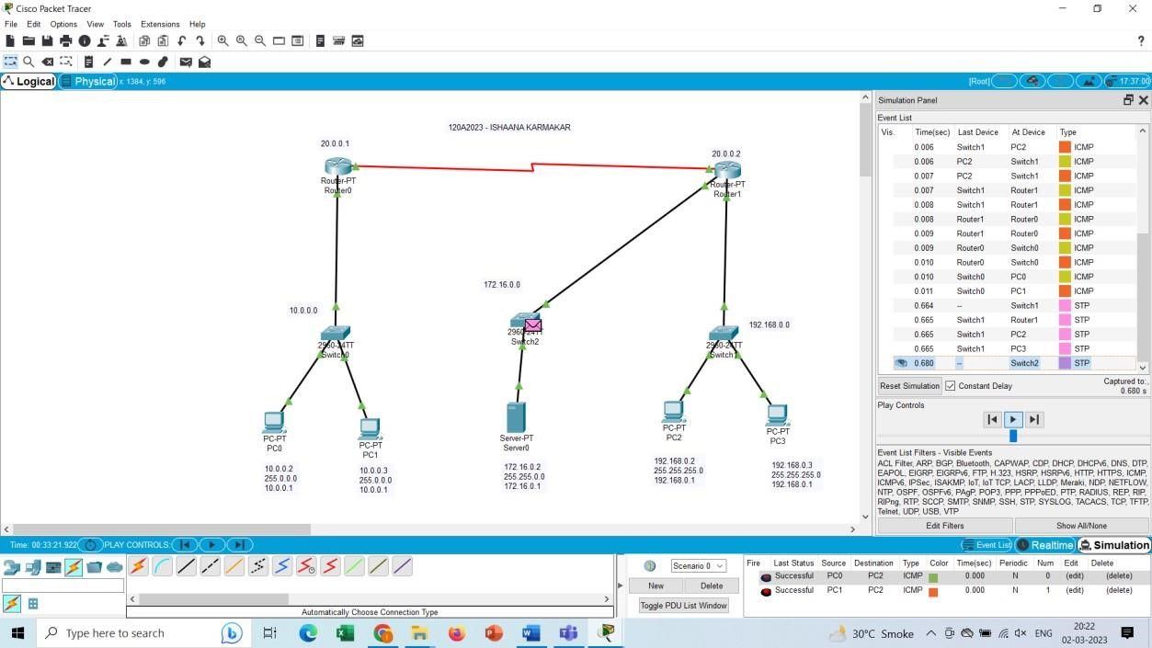

**CONCLUSION:**

Static routing implementation using cisco packet tracer is performed successfully. Connections between the devices and packet flow sequences is also studied.